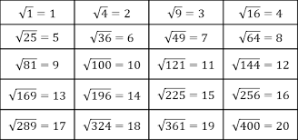
Success Work Academy
Timed Test
Square Root

