Success Work College Preparatory Academy
Middle School
Timed Test_ Powers of 2, 3,10

You should also know a chunk of the powers of 2...
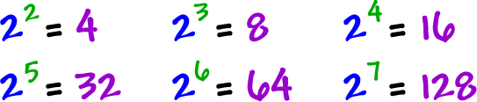
Some of the 3's...
And how the 10's work:
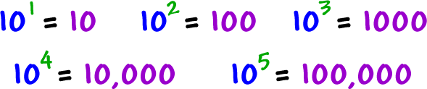
For the powers of 10, you just look at what the exponent says and put that many zeros on! Easy!

