Success Work Academy
Timed Test-Perfect Cubes

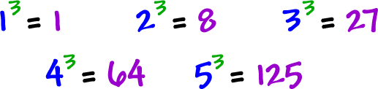
I'll bet you can guess why these are called "cubes!"
Yep, they are the volumes of cubes!
